
Administrative Access allows specified Manager Users to grant or restrict access to various features of Web Control. The Manager User with Administrative Access can:
- Grant the Administrative Access right to other Manager Users
- Modify any users’ role (such as making a Standard User a Manager User)
- Grant or restrict any users’ privileges, including the ability to see the Reports and other specified tabs or send Broadcast Emails
- Add or replace users
When a dealership's Web Control account is established, a Manager User who has access to the dealership is given Administrative Access. He or she can then give Administrative Access to other Manager Users in the dealership as appropriate.
Grant Administrative Access to Other Manager Users
Dealerships can have one or more Manager Users with Administrative Access. Having more than one user with Administrative Access allows multiple people grant or restrict privileges to other users.
To grant Administrative Access to Manager Users:
- Click the Settings link.
- From the User Settings section, click List Users.
- Find the Manager User to whom you want to grant Administrative Access and click the user’s name.
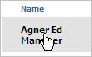
- Click the Edit Access link at the top of the page.
- In the User section, select Yes from the Administrative Access list.
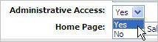
- Click Update User.

Modify a User’s Role
The Manager User with Administrative Access can modify a user’s role which allows the dealership to quickly manage which users are Manager Users and which users are Standard Users.
To modify a user’s role:
- Click the Settings link.
- From the User Settings section, click List Users.
- Find the user whose role you want to change, and click the user’s name.
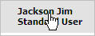
- Click the Edit Access link at the top of the page.
- In the User section, select the role you want from the Role list.
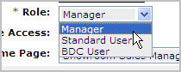
- Click Update User.

Grant or Restrict Privileges
The Manager User with Administrative Access can grant or restrict other users’ ability to see parts of the Web Control system or perform certain actions.
To grant or restrict a user’s privilege:
- Click the Settings link.
- From the User Settings section, click List Users.
- Find the user whose role you want to change, and click the user’s name.
- Click the Access link at the top of the page.
- In the Privileges section, select Yes or No for the various options, which include the ability to:
  - View Reports
  - View Customer Management
  - View DMS Sales Doc (Note: If choose No for View Reports, then the system will set DMS Sales Doc to No because the DMS Sales Doc is accessed from the Report section.)
  - View Inventory Management
  - View Showroom Management
  - Send Broadcast Email
- Click Update User.
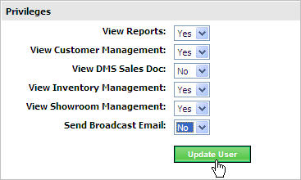

Add or Replace a User
The Manager User with Administrative Access can add new users or replace existing users. Any addition or replacement needs approved by Web Control Support before the user can access the system.
To add a user:
- Click the Settings link.
- From the User Settings section, click List Users.
- Click Add User.
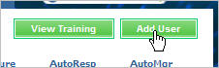
- Complete the User Maintenance form.
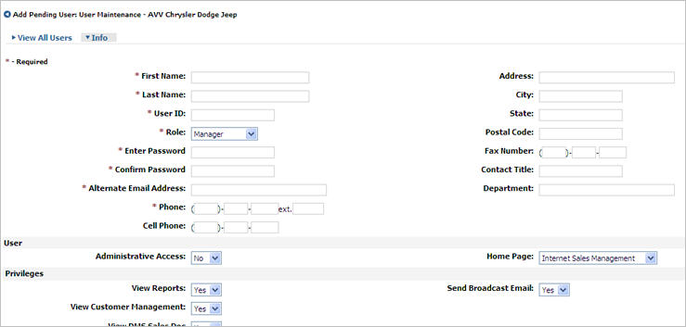
- Click Create User.
Important Notes:
  - The new user may be in pending status for up to 24 business hours.
  - The new User now appears in the Dealership Users List under the “Created Users (Not Yet Approved by AVV Support)” heading at the bottom of the list.
  - The Web Control system notifies Customer Service of the new user so they can review and approve the new user's account.
  - The Manager User who created the account and the new user receive an email when the process is complete.
To replace a user:
- Click the Settings link.
- From the User Settings section, click List Users.
- Click the name of the user you want to replace.
- Click Replace User.
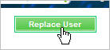
- Overwrite the appropriate fields in the Replace User form.
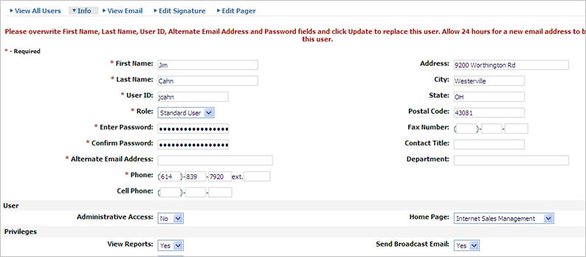
- Click Replace User.
Important Notes:
  - The newly assigned user may be in pending status for up to 24 business hours.
  - The new assigned user now appears in the Dealership Users List under the “Created Users (Not Yet Approved by AVV Support)” heading at the bottom of the list.
  - The Web Control system notifies Customer Service of the new user so they can review the replacement and assign an email address.
  - The Manager User who created the account and the newly assigned user receive an email when the process is complete.

