
The Edit/Export Prospect Information feature allows you to perform three different tasks:
- Change Prospects' Sales Status
- Reassign Prospects to Another Salesperson
- Export Prospect Information
Each task gives you the opportunity to either make changes to multiple prospects at one time or to gather information about multiple prospects at one time.
Change Prospects' Sales Status
The purpose of the Change Prospects' Sales Status task is to update the sales status of one or more prospects based on specific criteria selected by you. For example, if you want all prospects assigned to a specific salesperson to be moved from one status to another, you can change them all at one time using this feature.
To complete the Change Prospects' Sales Status task:
- Click the Settings tab.
- From the Batch Activities section, click Edit/Export Prospect Information.
- Select Change Prospects' Sales Status, and click Next.
- In Step 1: Select Dealership/Salesperson Information, select the Dealership (if applicable) and the Salesperson(s) whose prospects' status need updated. Click Proceed to Step 2 of 5.
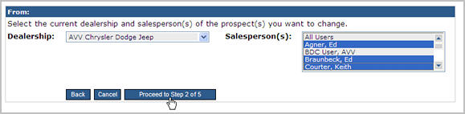
- In Step 2: Select Sales Statuses, select the Current Sales Status of the prospects and the New Sales Status of the prospects, and click Proceed to Step 3 of 5.
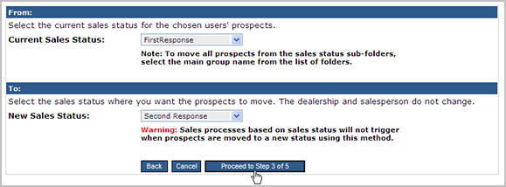
Important Note:
  - Prospects moved to a new status by the Edit/Export process will not trigger sales processes based on sale statuses.
  - The New Sales Status cannot be a group (ACTIVE, ALL LOST, etc.). If you select a group, the prospects will not update correctly.
- In Step 3: Find Prospects, choose your search criteria to find the prospects whose status you want to change, and click Proceed to Step 4 of 5.
- In Step 4: Select Prospects, select the prospects whose status you want to change, and click Proceed to Step 5 of 5.
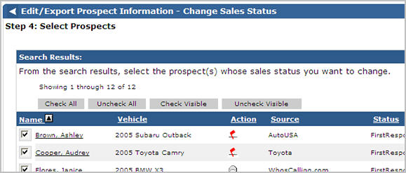
Important Notes:
- All prospects are selected by default. If you do not want to change a status, clear the check box next the prospect's name, or use the Check and Uncheck buttons that display above the Search results to select and clear check boxes.
- Click the column headers to sort the Search Results. By default, the results are sorted by last name

- In Step 5: Confirm and Complete, click Change Sales Status to change the prospects' status.
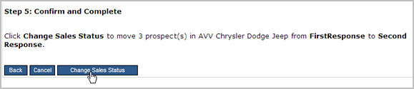
- When the change is complete, click Cancel to return to the Settings page, or click Start New/Edit Export to begin a new edit or export.
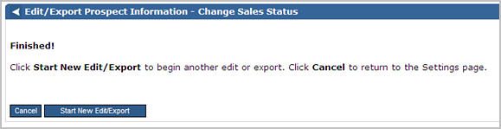

Reassign Prospects to Another Salesperson
The purpose of the Reassign Prospects to Another Salesperson task is to update the Salesperson assignment of one or more prospects based on specific criteria selected by you. For example, if you have a salesperson who is taking on a new role in the dealership and no longer will work directly with prospects, you can reassign all prospects to another salesperson at one time.
To complete the Reassign Prospects to Another Salesperson task:
- Click the Settings tab.
- From the Batch Activities section, click Edit/Export Prospect Information.
- Select Reassign Prospects to Another Salesperson, and click Next.
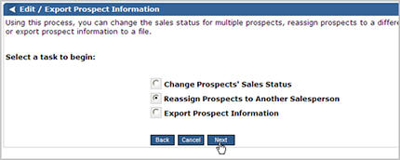
- In Step 1: Select Dealership/Salesperson Information:
  - In the From section, select the Dealership (if applicable), and the Salesperson(s) whose prospects you want to move.
  - In the To section, select the Dealership (if applicable), and the Salesperson to which the prospects will be assigned. You can only reassign prospects to one salesperson at a time.
- Click Proceed to Step 2 of 4.
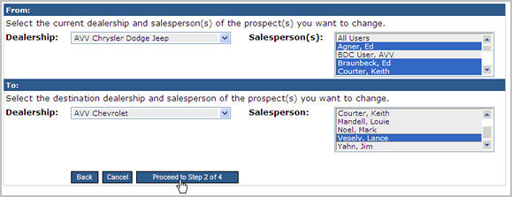
- In Step 2: Find Prospects, choose your search criteria to find the prospects whose assignment you want to change, and click Proceed to Step 3 of 4.
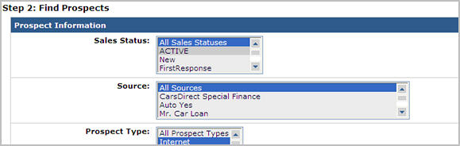
- In Step 3: Select Prospects, select the prospects whose assignment you want to change, and click Proceed to Step 4 of 4.
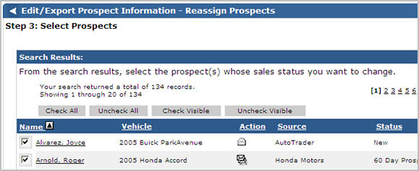
Important Notes:
- All prospects are selected by default. If you do not want to change a status, clear the check box next the prospect's name, or use the Check and Uncheck buttons that display above the Search results to select and clear check boxes.
- Click the column headers to sort the Search Results. By default, the results are sorted by last name.
- In Step 4: Confirm and Complete:
  - If applicable, select a new sales status for any prospects whose status will not match when it is reassigned (The list of sales statuses only appears when a new status needs selected, and this typically occurs when reassigning from a salesperson in one dealership to a salesperson in another dealership).
  - Click Reassign Prospects.
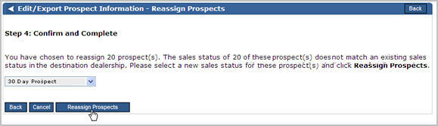
- When the reassignment is complete, click Cancel to return to the Settings page, or click Start New/Edit Export to begin a new edit or export.
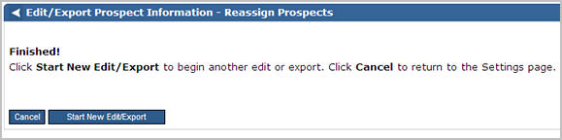

Export Prospect Information
The purpose of the Export Prospect Information task is to create a file that includes prospect information for one or more prospects.
To complete the Export Prospect Information task:
- Click the Settings tab.
- From the Batch Activities section, click Edit/Export Prospect Information.
- Select Export Prospect Information, and click Next.
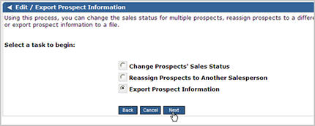
- In Step 1: Select Dealership/Salesperson Information, select the Dealership (if applicable) and the Salesperson(s) whose prospects you want to export to a file. Click Proceed to Step 2 of 4.
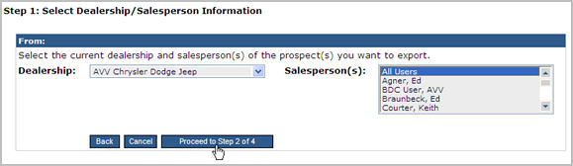
- In Step 2: Find Prospects, choose your search criteria to find the prospects you want to export, and click Proceed to Step 3 of 4.
- In Step 3: Select Prospects, select the prospects for the export, and click Proceed to Step 4 of 4.
- In Step 4: Export and Complete, click Export Prospects to create the file.
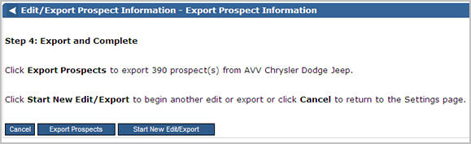
- Click Save to save the file.
Important Note:
- It is best to chose Save instead of Open when exporting prospects. If you save the file, you can open it outside of Web Control and work with data more easily.
- Click Cancel to return to the Settings page, or click Start New/Edit Export to begin a new edit or export.

