The Auto Manager function allows a manager to control where email leads are directed by the Web Control Internet Sales Management (ISM) system. Instead of the manager receiving all the mail and having to manually forward it, auto manager sorts and redirects the email to the preferred Users based on criteria specified by the manager. Only the main manager, the one having the sales@dealername.dealerspace.com email address in their account, should have Auto Manager configured. (Identified in Settings/Email Administration/List Dealer Email Accounts.) The System will not recognize an auto manager configured for additional Users.
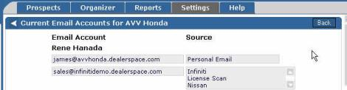
Multiple email filters may be configured. The location of the filter in the list will decide the order of importance of the filter. The top filter is the first extracted, the rest of the filters are extracted in order until the last in the list of filters is extracted. The filters must be arranged by the manager in order of importance.
Business hours and individual User schedules must also be configured. The system checks the User’s schedule before assigning leads to them.

Configure / Edit Filters
To configure or edit an Auto Manager filter:
- Click "Settings" at the top of the Web Control page.
- Scroll down the Settings list to System Administration.
- Select "Auto Manager" from the Settings listing. The Select Manager page appears.
- From the "Select a manager" drop down list on the "Auto Manager" screen, select the main sales manager on the system. | 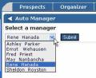
The Auto Manager Setup page with existing filters and new filter options appears.
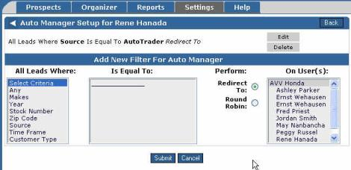
- To edit an existing filter, click the corresponding "Edit" button. The selected filter will display on the "Edit Auto Manager Filter" screen. Modify the filter, then click "Submit".
- To create a new filter, select the criteria for the new filter at the bottom of the "Auto Manager Set Up" screen.
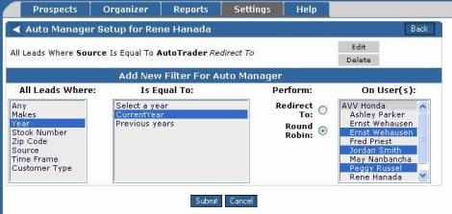
- Select one of the options under “All Leads Where:”.
Depending on the selection, there may or may not be subcategories and options to choose from in the "is equal to" selection box.
- Select one of the options in "is equal to".
Hold down the Ctrl key while clicking multiple choices to select more than one option. Additional subcategories and options may be displayed based on your selections. Choose those that best fit your filter intentions.
- Select a "perform":option.
  - Click the button corresponding to "Redirect to" to simply move the leads to another user.
  - Select "Round Robin" to have the leads evenly distributed between two or more users.
Note: The scheduled days off settings will affect the round robins and redirects. If a user is scheduled off, the lead will be forwarded to that user's scheduled back up.
- Click the user(s) to be selected for this filter from the "on user(s)" scroll box,
To select multiple users, hold down the Ctrl key on the keyboard while clicking the users from the list. Multiple users are an option only for round robin, redirect applies to a single user.
- Click "Submit" to save and activate the auto manager filter. Click "Cancel" to return to the settings menu without saving the filter or edits.

Filter Order
If there is more than one filter in the Auto Manager, arrows will appear on the left side of each filter. The location of the filter in the list will decide the order of importance of the filter. The top filter is the first extracted, the rest of the filters are extracted in order until the last in the list of filters is extracted.
If the possibility exists that multiple filters will apply to individual leads, place the filters in order of importance with the most important filter listed first. Each filter can also be edited or deleted by clicking the "Edit" or "Delete" button.
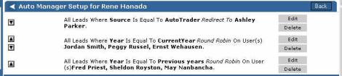
Click the arrows to move the position of the filter up and down in the list.

