Auto Responses can be used to quickly send an email reply to new leads coming into the dealership. Auto Response templates include an automatic delivery schedule. They can be very general in nature or include information specific to the prospect's make and model of interest.

Create an Auto Response:
- Click the "Settings" tab at the top of the Web Control page.
- Scroll down the page to "Email Administration".
- Click "Add/Edit Auto Response Template".
The Auto Response Template page opens.
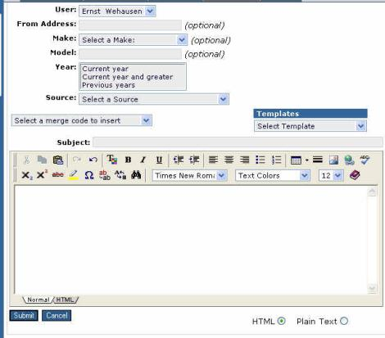
The “From Address” text box should contain the return address to which any prospect response needs to be directed. If no entry is made, the default "From Address" will be the current user’s email address in the Internet Sales Management system.
To associate a make with the new Auto Response, click the down arrow to display the list of makes, click a make to select it. If no selection is made all makes will apply.
- Type the model name to associate with this template. An optional setting and no entry is necessary. No selection will default to all models.
- From the "Year" selection box, click the range of years to be associated with this Auto Response template. Leaving this option out will default to all years.
- Type the text of the Auto Response in the text window.
- Click the Normal tab to select the format. Templates should always be saved in the "Normal" or WYSIWYG (what you see is what you get) view.
- Select "HTML" to send email to prospects in HTML format
- Type a template Title in the "Subject". If no subject line is entered, the subject line will default to "RE: Original subject line on prospect's lead."
- Click "Submit" to save the template schedule delivery for this Auto Response template.

Merge Codes
Merge codes are available to automate the process of quickly customizing and personalizing contact with prospects. However, Merge codes are not recommended for Auto Response emails. The information in the prospect's profile has not yet been reviewed by the salesperson and the selected text may not be appropriate. For more information, refer to the AVV Help.

Edit an Auto Response template:
- Open the "Auto Response Template" screen from the "Settings" page.
- Select any of the existing templates from the top of the "Auto Response Template" screen.
- Click a template to display it on the "Edit Auto Response Template" screen.
- Edit the information and text in the template as with a new template.
- Click "Submit" to update and save the template.

Schedule Delivery:
"Submit" saves the Auto Response Email Template and takes the User to the “Schedule Auto Response Delivery” page. The User must select a delivery schedule.
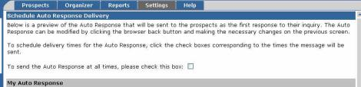
- Click the "Check this box if you want to send the Auto Response all the time" check box to schedule an Auto Response template for 24 hour delivery everyday
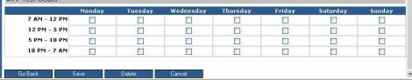
- Click the boxes corresponding to the time frames the template should be sent to customize the times that the Auto Response will be sent in response to new leads.
- Click "Go Back" to return to the "Auto Response Template" page and modify the template.
- Click "Save" to save and update the template and delivery settings.
- Click "Delete" to delete the Auto Response template and delivery settings. The template will be permanently deleted and cannot be restored.
- Click "Cancel" to return to the "Settings" menu without saving changes made to the Auto Response template.

