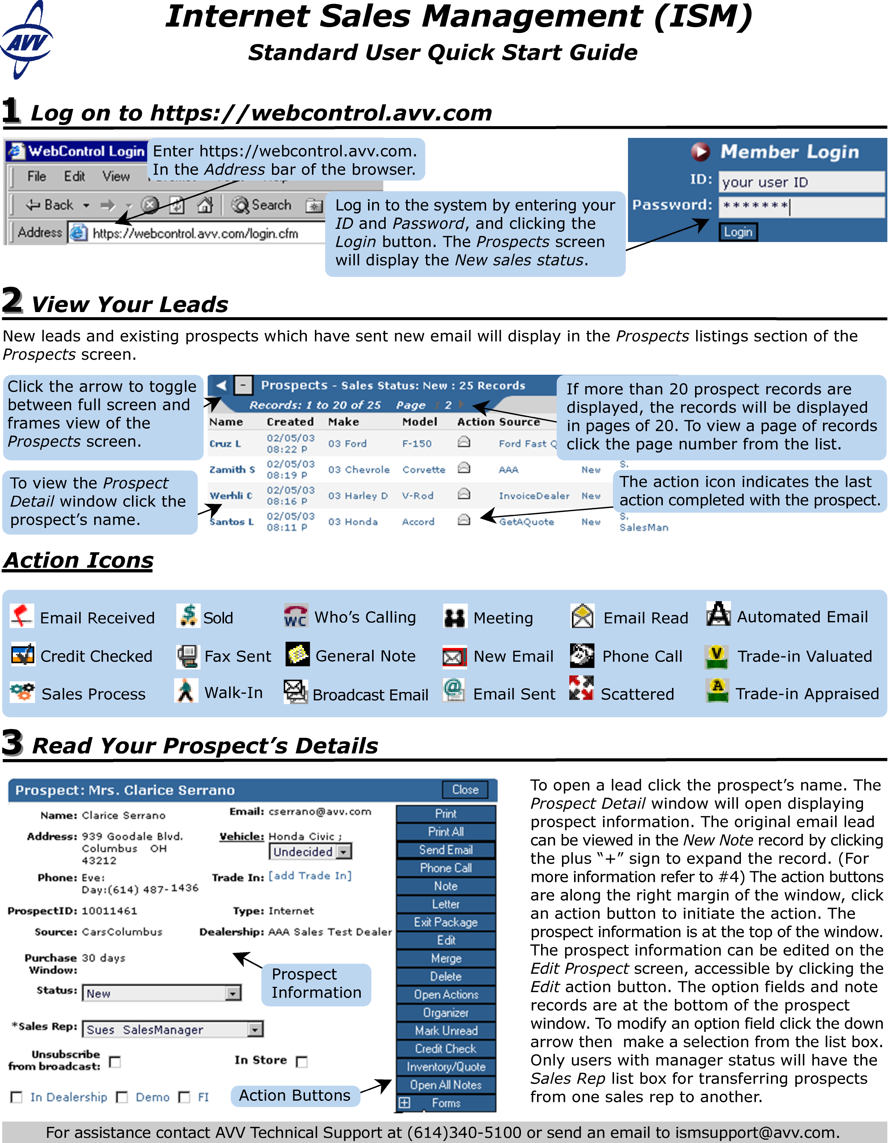
For assistance contact AVV Technical Support at 614-839-7888 or send an email to ismsupport@avv.com
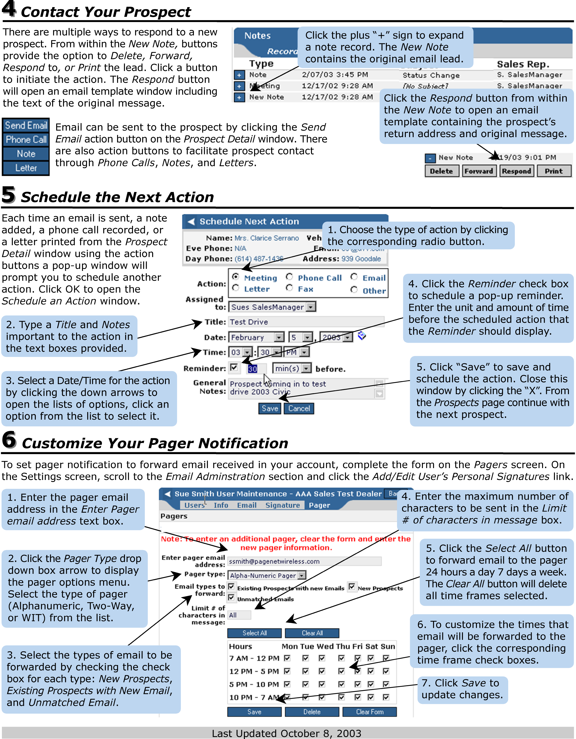
For assistance contact AVV Technical Support at 614-839-7888 or send an email to ismsupport@avv.com

